**Configure general server settings:**

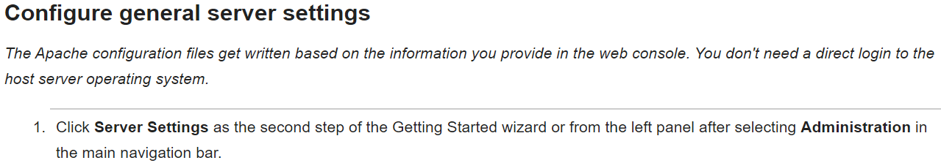

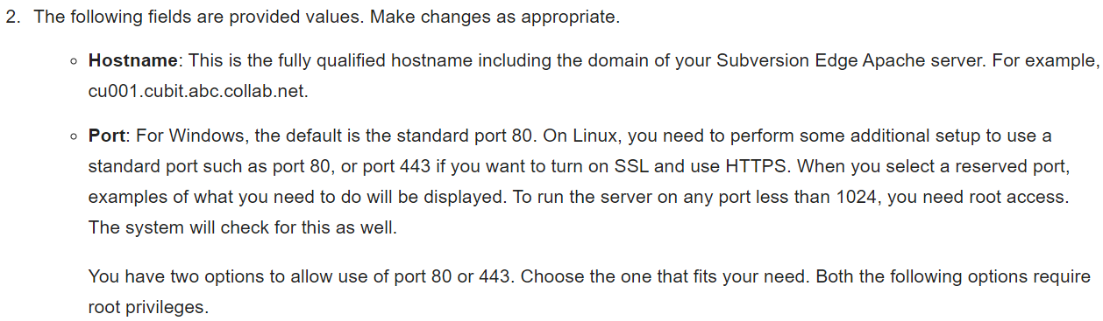

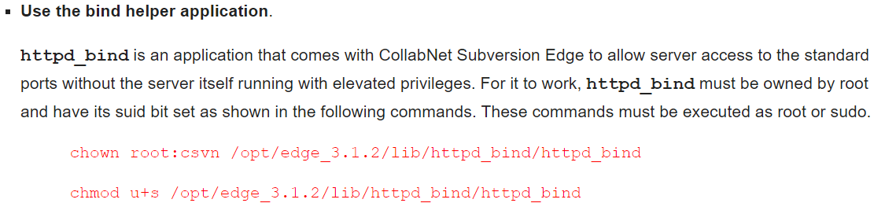

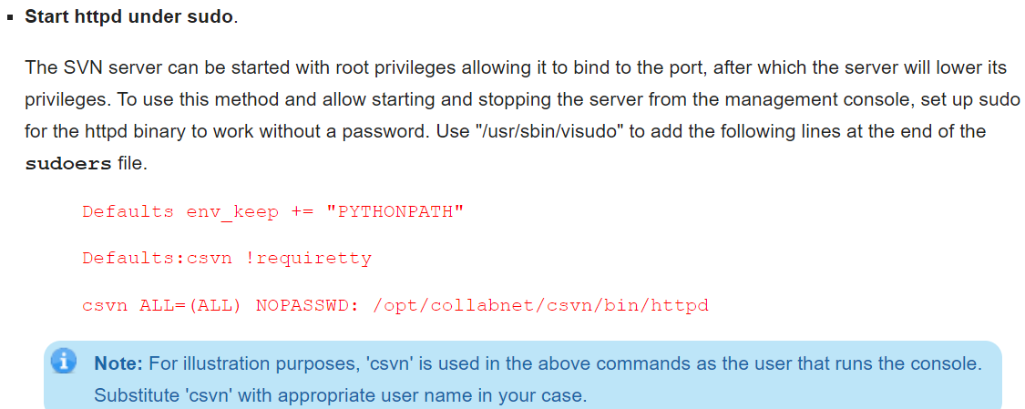

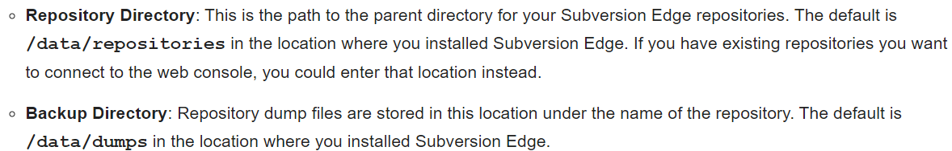

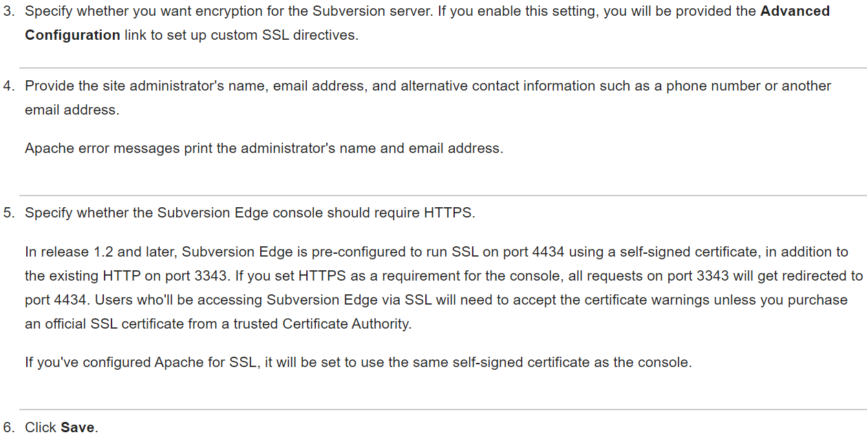

We can see the 4 tabs on top of the screen of svn page in browser which are “repositories”, “users”, “administration” & “extensions”

**Repositories:**

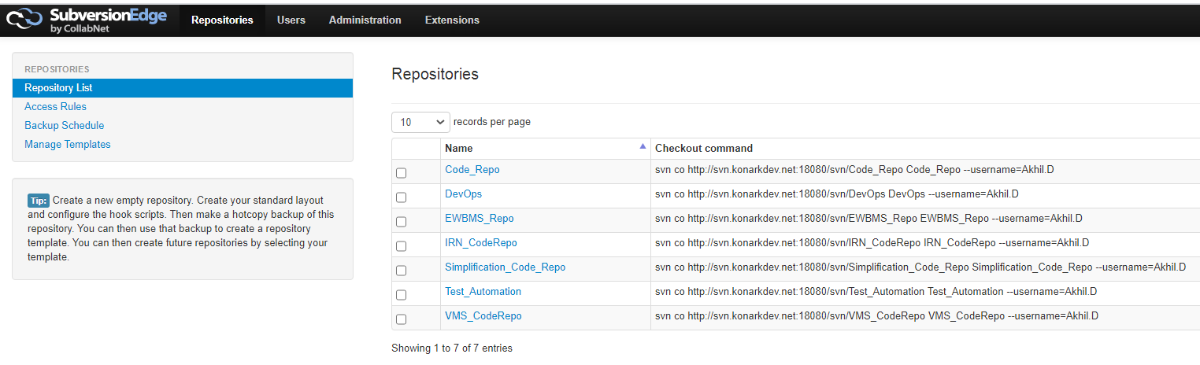

* We can see all the repo details here along with the command to check out the code as above.

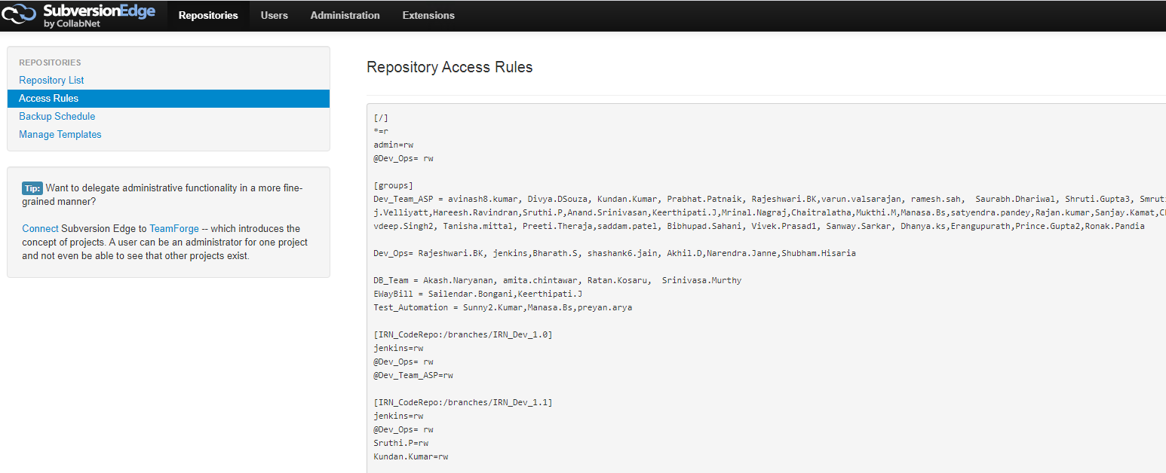

* Then under access rules, we can add the “repository:branch” and give the read or read/write permissions to an user or the group as above.

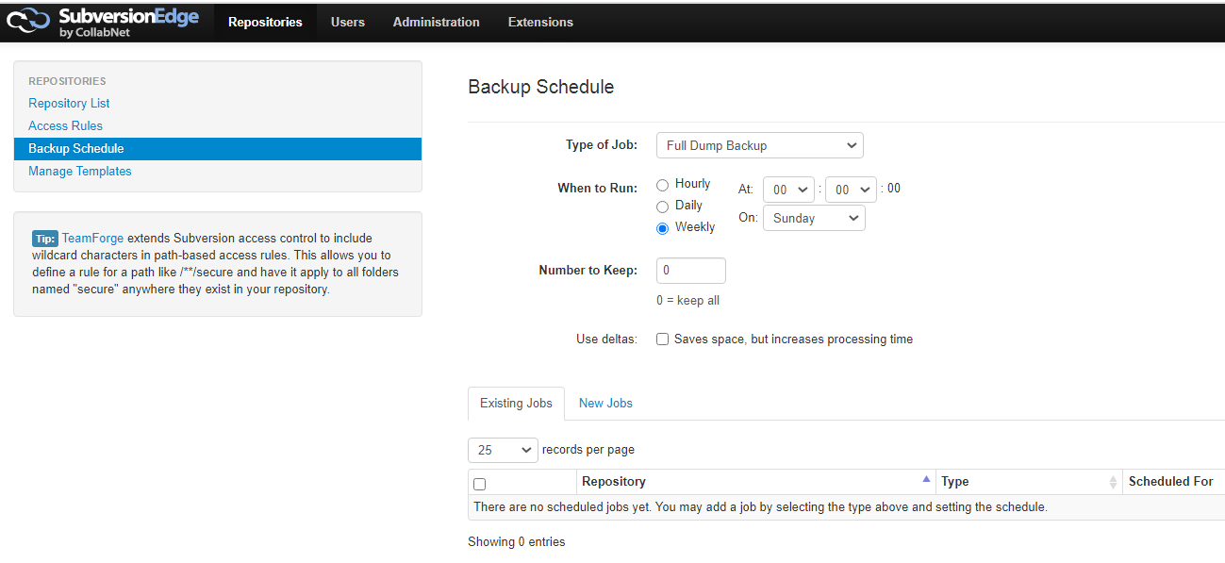

* We can also schedule backups from UI as above.

**User creation and permissions in subversion edge:**

* Click on users and then create user by selecting the role as below.

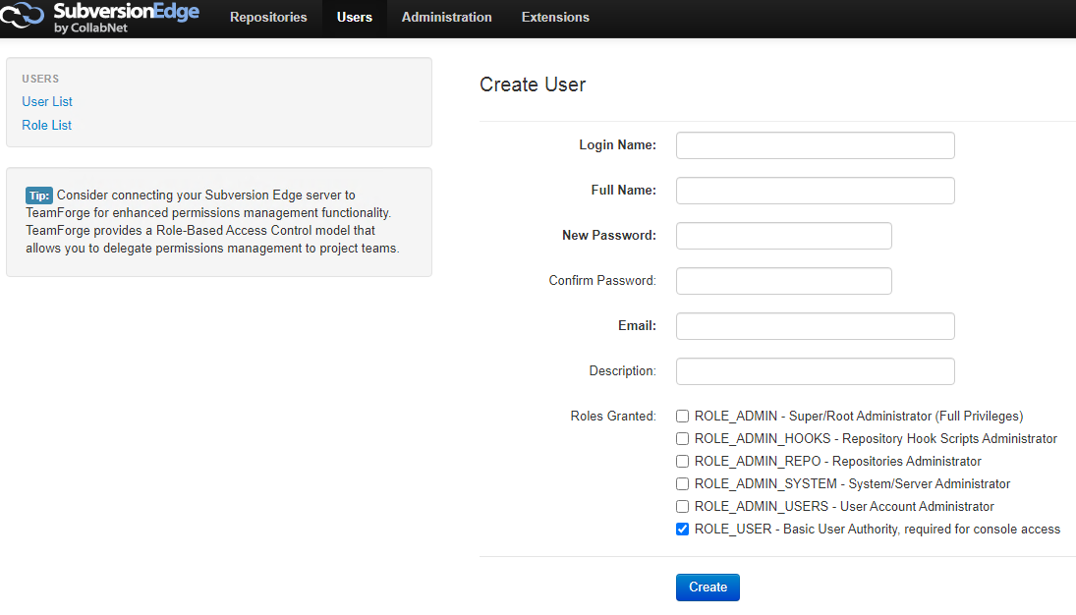

* If we want, we can add the roles to existing users as below.

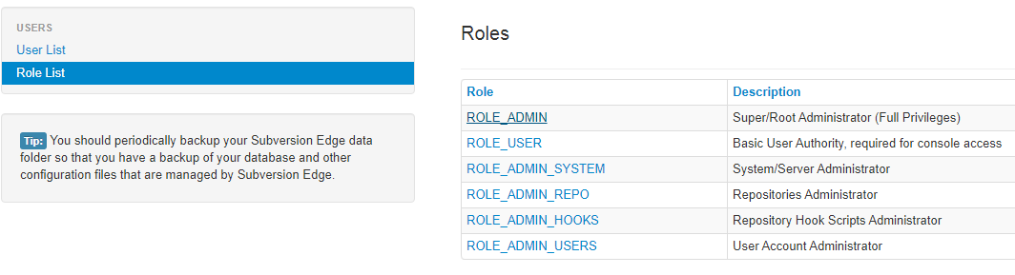

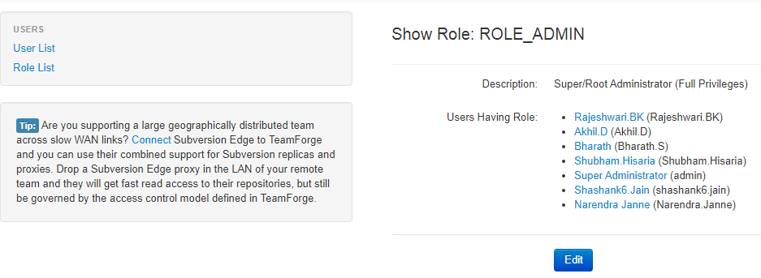

* We can give the permissions in web as below.

**Repositories🡪access rules**

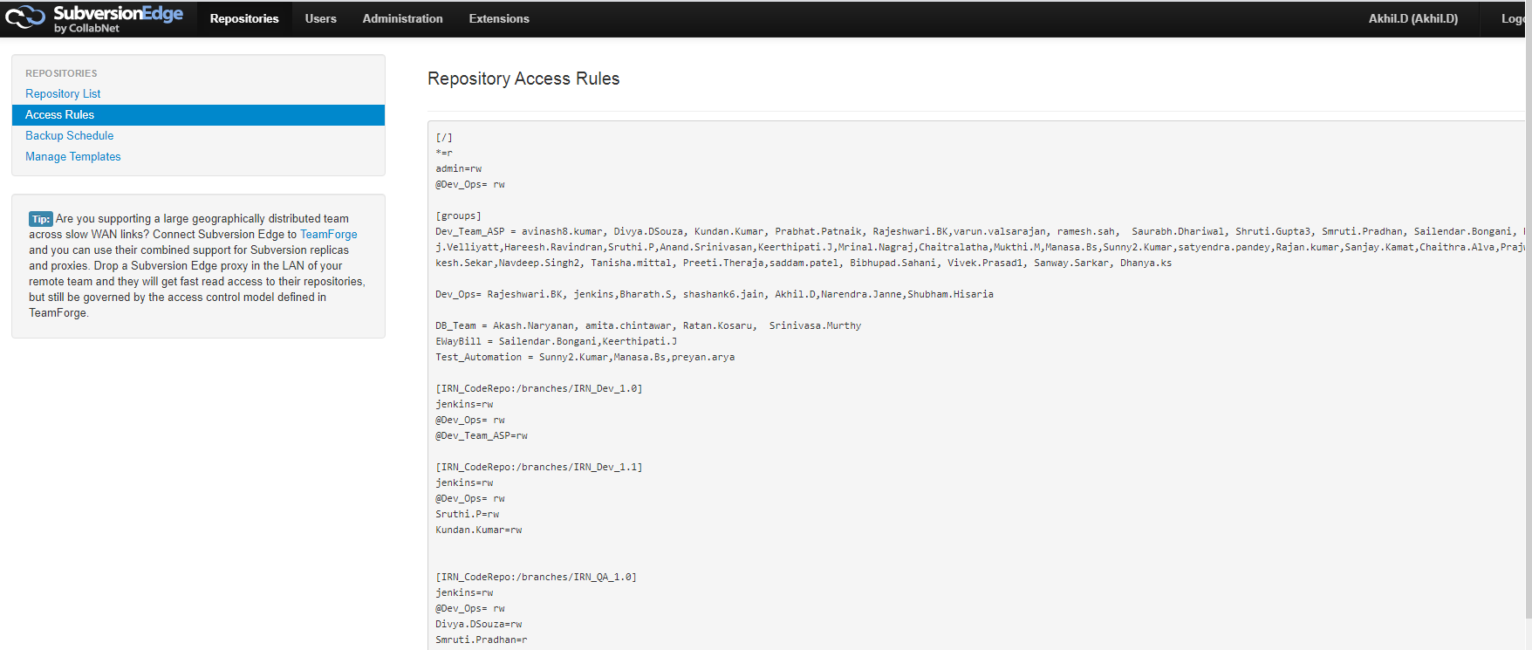

**Administration:**

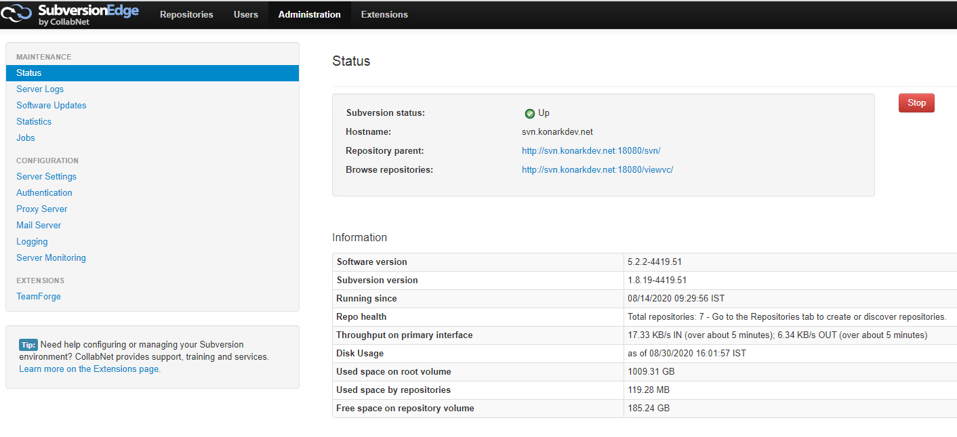

* Here, it comes with the repository URLs as the **“hostname:port”** which we add in server settings. We can use those two URLs to view the repos and data inside it from the browser itself.

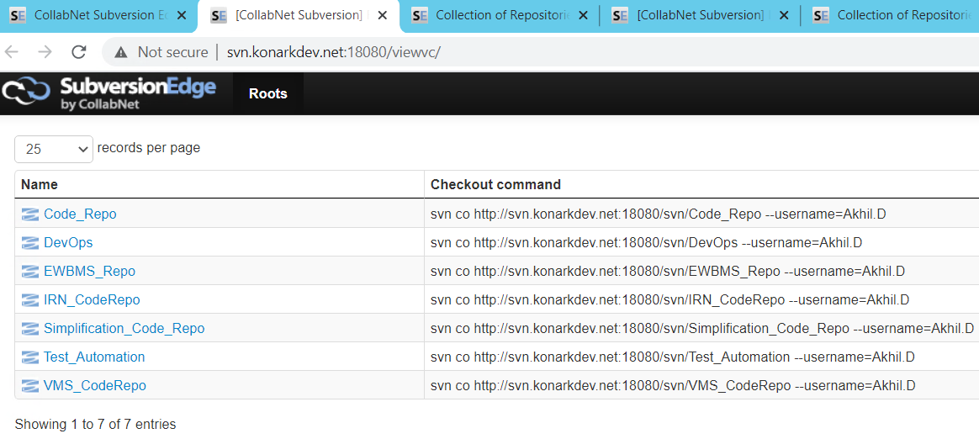

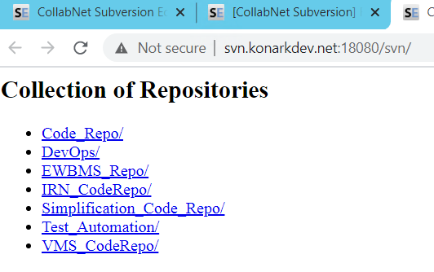

We can use the same URL which is with the serverDNS and port to pull the code from tortoise SVN. Or we can also use in different ways as below.

* <http://ci-sh-sv001:18080/svn/>
* <http://svn.konarkdev.net:18080/svn>
* <http://10.1.3.6:18080/svn>

all these three works the same way either with server DNS name or hostname or IP as above.

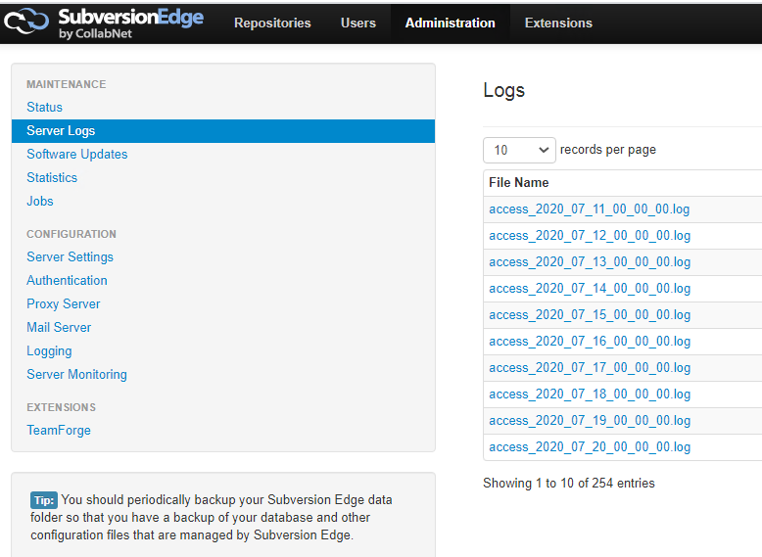

We can also see the logs from UI as above. Or we can get the same from the server in below path.

* **<csvn_path>/data/logs**

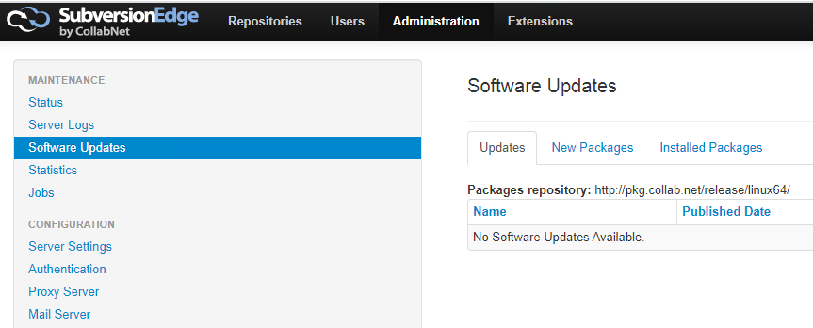

* We can also check for the software updates as above.

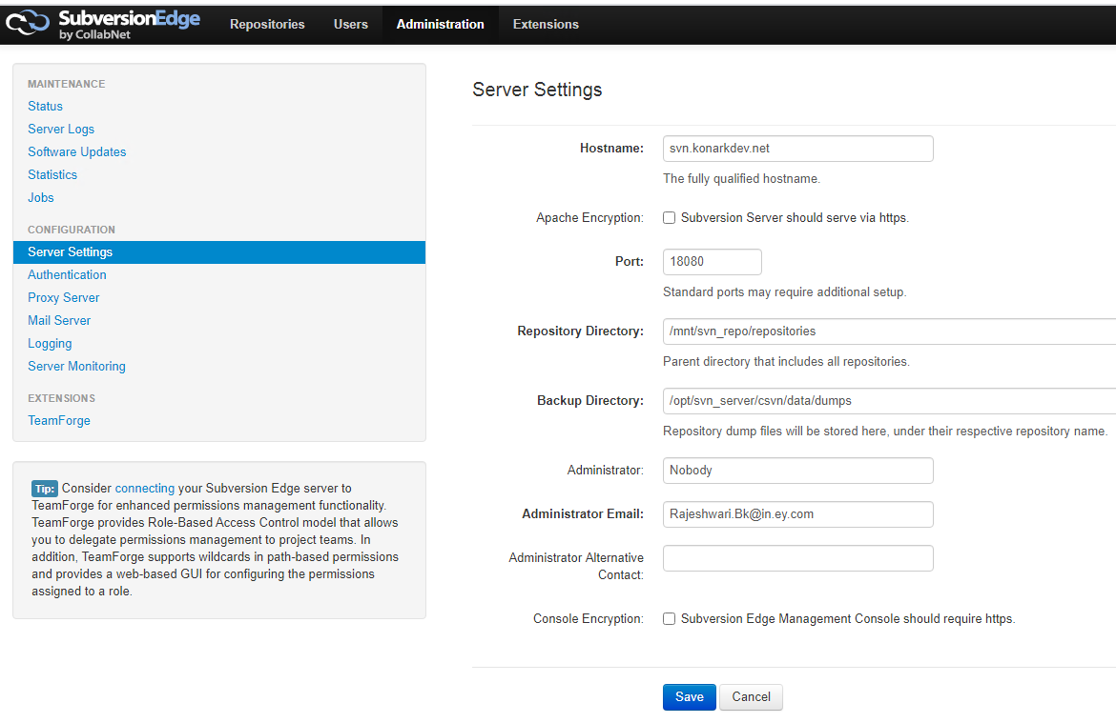

* Then under server settings, it automatically takes the fully qualified hostname/DNS. We need to give the port there which will be used to pull or push the code. The same port needs to be opened in security groups as well.
* If it takes private DNS automatically and we want to change to public DNS. We can do that as well
* We need to give the repository path where our repositories should get created inside the server. By default, it takes the repository folder which is inside the “Data” folder where we installed csvn. We can change it as above if we want
* The same for backup directory as well. By default, it used dumps directory even when we take the backup using **svnadmin** script from the server.

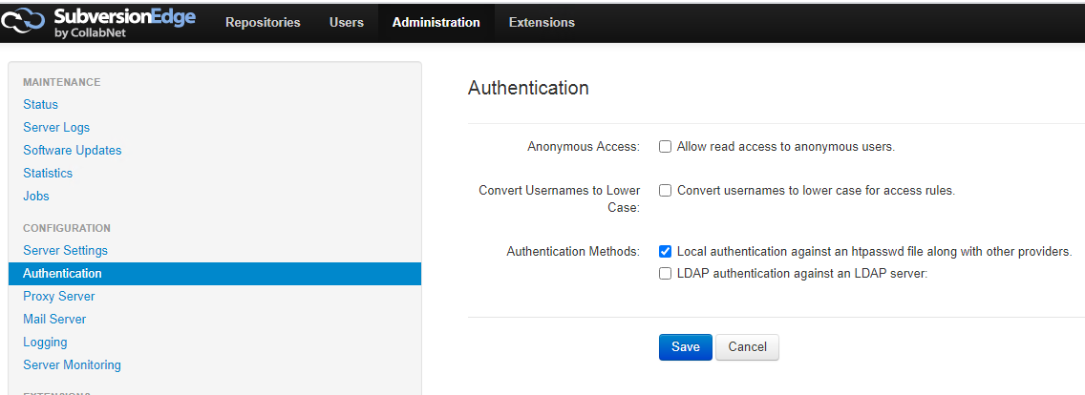

* We can also select the authentication type as above.
* We can add proxy, mail servers if required.

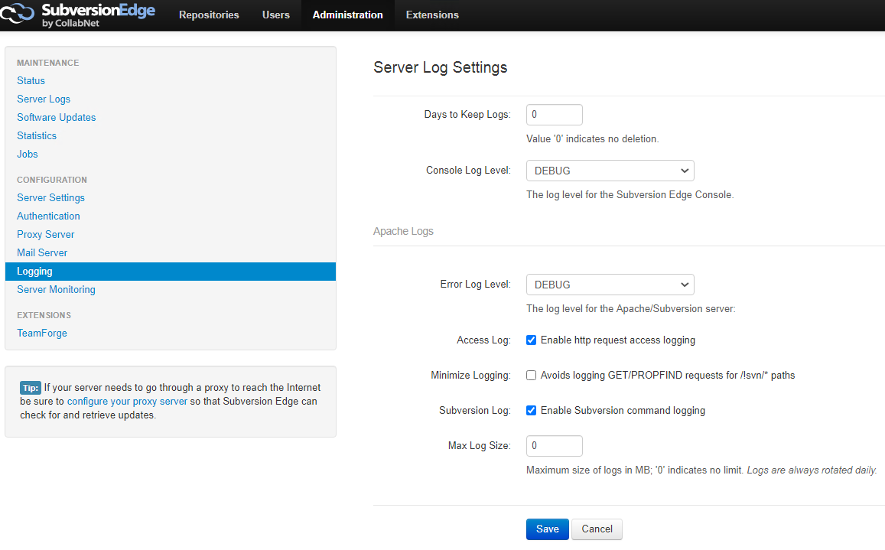

* Also, the server logging in can be enabled as above with the different log levels.

**Note:**

* **“/bin”** folder in svn contains all the executable files which are required for stopping or starting csvn and taking backup
* **“/data”** folder contains the default folders which stores the details of “repositories”, “logs”, “conf”, “dumps” etc.